Tables
Table 1: Dataset of blubber samples collected from 35 stranded gray whales and analyzed for concentrations of corticosteroid hormones and lipid content in relation to sex, age class, cause of death, body and carcasses conditions
MMSNW | ID | UME | Date of necropsy | State | Carcass Code | Body Condition | Age Class | Sex | Cause of Death | Lipid content (%) | Cortisol (ng/g) | Corticosterone (ng/g) | Aldosterone (ng/g)
WDFW | 201730 | Pre-UME | 5/2/17 | WA | 3 | Good | Immature | M | Entanglement | 28.76 | 6.40 | 3.00 | 0.52
PSU | 190430 | UME 2019 | 4/30/19 | WA | 3 | Fair | Adult | F | Undetermined | 2.60 | 3.20 | 0.16 | 0.06
PSU | 190417 | UME 2019 | 4/17/19 | WA | 2.5 | Fair | Adult | F | Trauma | 16.39 | 1.90 | 0.52 | 0.07
PSU | 180413 | Pre-UME | 4/15/18 | WA | 3.5 | Good | Immature | M | Entanglement | 59.30 | 1.20 | 0.54 | 0.15
PSU | 190402 | UME 2019 | 4/2/19 | WA | 2.5 | Fair | Adult | F | Undetermined | 24.15 | 3.30 | 0.33 | 0.10
WDFW | 2019047 | UME 2019 | 6/3/19 | WA | 3 | Poor | Immature | M | Nutritional stress | 2.21 | 1.00 | 0.16 | 0.04
CRC | 1278 | Pre-UME | 7/30/13 | WA | 3 | Fair | Adult | F | Trauma | 2.29 | 8.90 | 0.27 | 0.30
CRC | 1587 | Pre-UME | 5/24/17 | WA | 3 | Good | Immature | F | Trauma | 13.10 | 43.90 | 1.67 | 0.41
CRC | 1724 | UME 2019 | 5/16/19 | WA | 2.5 | Poor | Adult | F | Nutritional stress | 5.90 | 0.10 | 0.39 | 0.05
CRC | 1732 | UME 2019 | 6/1/19 | WA | 2.5 | Poor | Adult | M | Nutritional stress | 23.88 | 0.60 | 0.44 | 0.04
CRC | 1714 | UME 2019 | 4/18/19 | WA | 3.5 | Poor | Immature | F | Undetermined | 18.65 | 2.10 | 3.17 | 1.52
CRC | 1665 | Pre-UME | 6/28/18 | WA | 2 | Poor | Immature | F | Trauma | 50.35 | 14.20 | 21.66 | 0.72
CRC | 1723 | UME 2019 | 5/15/19 | WA | 3 | Poor | Immature | F | Nutritional stress | 12.74 | 8.30 | 4.65 | 2.35
CRC | 1720 | UME 2019 | 5/9/19 | WA | 2.5 | Poor | Immature | M | Trauma | 4.59 | 1.10 | 3.60 | 0.09
CRC | 1429 | Pre-UME | 8/20/14 | WA | 3 | Good | Immature | F | Undetermined | NA | 2.70 | 1.51 | 0.81
CRC | 1740 | UME 2019 | 7/6/19 | WA | 2.5 | Poor | Adult | M | Nutritional stress | 13.42 | 5.70 | 0.22 | 0.11
CRC | 1149 | Pre-UME | 4/20/11 | WA | 3.5 | Fair | Adult | F | Nutritional stress | 0.64 | 2.40 | 0.94 | 0.25
WDFW | 2019017 | UME 2019 | 2/23/19 | WA | 2 | Poor | Immature | F | Nutritional stress | 36.40 | 32.10 | 2.97 | 0.20
CRC | 1650 | Pre-UME | 4/20/18 | WA | 3 | Poor | Adult | F | Undetermined | NA | 10.30 | 1.69 | 0.09
CRC | 1035 | Pre-UME | 4/14/10 | WA | 2 | Fair | Adult | M | Trauma | 0.99 | 5.30 | 0.18 | 0.15
CRC | 1524 | Pre-UME | 4/30/16 | WA | 2.5 | Poor | Immature | F | Trauma | NA | 16.20 | 1.50 | 0.10
CRC | 1652 | Pre-UME | 5/8/18 | WA | 4 | Poor | Adult | F | Undetermined | NA | 4.00 | 7.85 | 14.45
CRC | 1712 | UME 2019 | 4/14/19 | WA | 2.5 | Poor | Adult | M | Nutritional stress | 5.37 | 1.50 | 0.19 | 0.05
WDFW | 2011090 | Pre-UME | 7/27/11 | WA | 2 | Poor | Immature | M | Trauma | 1.57 | 16.50 | NA | NA
CRC | 1593 | Pre-UME | 7/19/17 | WA | 3 | Good | Immature | F | Trauma | NA | 18.80 | 0.62 | 0.61
CRC | 1727 | UME 2019 | 5/26/19 | WA | 2.5 | Fair | Adult | M | Nutritional stress | 3.48 | 1.50 | 2.08 | 0.13
CRC | SKMMR2019-5-Er | UME 2019 | 5/5/19 | WA | 3 | Poor | Adult | F | Undetermined | 11.30 | 10.30 | 2.59 | 0.36
CRC | 1585 | Pre-UME | 5/10/17 | WA | 2.5 | Fair | Adult | F | Undetermined | NA | NA | 4.81 | 0.44
AKMMSN | 2019100 | UME 2019 | 6/16/19 | AK | 3 | Good | Immature | M | Nutritional stress | 15.47 | 9.70 | 0.46 | 0.08
AKMMSN | 2019198 | UME 2019 | 5/9/19 | AK | 2 | Good | Adult | M | Predation | NA | 1.60 | 0.17 | 0.04
AKMMSN | 2018088 | Pre-UME | 6/28/18 | AK | 3.5 | Poor | Adult | F | Trauma | NA | 1.20 | 0.12 | 0.03
AKMMSN | 2018158 | Pre-UME | 8/2/18 | AK | 4 | NA | Unknown | F | Predation | 11.30 | 0.80 | 0.58 | 0.31
AKMMSN | 2019031 | UME 2019 | 5/14/19 | AK | 3 | Good | Adult | F | Nutritional stress | 27.24 | 4.90 | 0.56 | 0.09
AKMMSN | 2017109 | Pre-UME | 7/28/17 | AK | 2 | NA | Unknown | F | Predation | NA | 2.80 | 0.11 | NA
AKMMSN | 2019018 | UME 2019 | 5/9/19 | AK | 3.5 | Good | Adult | M | Nutritional stress | 56.90 | 10.30 | 0.46 | 0.17

Table 2: List of samples with high concentrations of corticosteroid hormones and identified as outliers from the exploratory data analysis

MMSNW | ID | UME | Date of necropsy | State | Carcass Code | Body Conditions | Sex | Age class | CoD | Lipid content (%) | Cortisol (ng/g) | Corticosterone (ng/g) | Aldosterone (ng/g)
CRC | 1587 | Pre-UME | 5/24/17 | WA | 3 | Good | F | Immature | Trauma | 13.1 | 43.9 | 1.67 | 0.41
CRC | 1665 | Pre-UME | 6/28/18 | WA | 2 | Poor | F | Immature | Trauma | 50.35 | 14.2 | 21.66 | 0.72
WDFW | 2019017 | UME 2019 | 2/23/19 | WA | 2 | Poor | F | Immature | Nutritional stress | 36.4 | 32.1 | 2.97 | 0.20
CRC | 1652 | Pre-UME | 5/8/18 | WA | 4 | Poor | F | Adult | Undetermined | NA | 4.0 | 7.85 | 14.45

Table 3: Hormone concentrations (ng/g) and percent lipid content across blubber depth for female (n=11) and male (n=8) stranded gray whales.
 |  | Cortisol ng/g |  |  | Corticosterone ng/g |  |  | Aldosterone ng/g |  |  | Lipid content %
Blubber Depth | Sex | mean | standard deviation | range | mean | standard deviation | range | mean | standard deviation | range | mean | standard deviation | range
Surface | F | 11.33 | 14.24 | 0.11-43.91 | 1.48 | 1.20 | 0.16-3.17 | 0.34 | 0.53 | 0.05-1.52 | 14.53 | 11.01 | 2.29-36.4
Medium | F | 4.83 | 6.22 | 0.12-16.95 | 0.76 | 0.47 | 0.28-1.52 | 0.05 | 0.03 | 0.02-0.11 | 0.93 | 0.66 | 0.12-1.6
Bottom | F | 8.58 | 9.11 | 0.17-27.8 | 0.71 | 0.62 | 0.07-1.75 | 0.05 | 0.04 | 0.02-0.12 | 0.24 | 0.27 | 0.03-0.7
Surface | M | 3.89 | 4.06 | 0.58-10.33 | 0.56 | 0.63 | 0.16-2.08 | 0.07 | 0.04 | 0.04-0.13 | 23.63 | 24.83 | 0.99-59.3
Medium | M | 2.95 | 3.58 | 0.52-10.96 | 0.79 | 0.69 | 0.15-1.87 | 0.07 | 0.11 | 0.01-0.26 | 3.65 | 3.19 | 0.53-8.29
Bottom | M | 3.06 | 3.70 | 0.42-10.87 | 0.59 | 0.37 | 0.13-1.16 | 0.15 | 0.24 | 0.003-0.43 | 12.81 | 16.08 | 0.28-34.3

Table S1: Complete dataset of samples used for blubber depth analysis (i.e., samples for which we analyzed multiple blubber layers). Highlighted are the whales with very high hormone concentrations, thus flagged as outliers .
MMSNW | Field ID | Blubber Depth | Sex | Age | Body condition | Carcass decomposition | Weight g | Cortisol ng/g | Corticosterone ng/g | Aldosterone ng/g | Lipid content %
CRC | 1035 | Bottom | M | adult | Fair | 2 | 0.1849 | 4.02 | 0.13
CRC | 1035 | Medium | M | adult | Fair | 2 | 0.2642 | 5.12 | 0.17 |  | 0.53
CRC | 1035 | Surface | M | adult | Fair | 2 | 0.183 | 5.26 | 0.18 |  | 0.99
CRC | 1278 | Bottom | F | adult | Fair | 3 | 0.3242 | 7.97 |  |  | 0.08
CRC | 1278 | Medium | F | adult | Fair | 3 | 0.2731 | 7.49 |  |  | 1.29
CRC | 1278 | Surface | F | adult | Fair | 3 | 0.207 | 8.85 |  |  | 2.29
CRC | 1429 | Bottom | F | juv | Good | 3 | 0.3551 | 4.55
CRC | 1429 | Medium | F | juv | Good | 3 | 0.5746 | 6.36
CRC | 1429 | Surface | F | juv | Good | 3 | 0.5078 | 2.71
CRC | 1524 | Bottom | F | sub-adult | Poor | 4.5 | 0.2515 | 10.94 | 1.02
CRC | 1524 | Medium | F | sub-adult | Poor | 3.5 | 0.2313 |  | 1.52
CRC | 1524 | Surface | F | sub-adult | Poor | 2.5 | 0.326 | 16.18 | 1.5
CRC | 1587 | Bottom | F | sub-adult | Good | 3 | 0.408 | 27.8 | 1.75 |  | 0.7
CRC | 1587 | Medium | F | sub-adult | Good | 3 | 0.4277 | 13.98 | 0.77 |  | 0.7
CRC | 1587 | Surface | F | sub-adult | Good | 3 | 0.195 | 43.91 | 1.67 |  | 13.1
CRC | 1712 | Bottom | M | adult | Poor | 2.5 | 0.109 | 1.34 | 0.35 |  | 0.74
CRC | 1712 | Medium | M | adult | Poor | 2.5 | 0.1333 | 1.18 | 0.88 | 0.01 | 3.03
CRC | 1712 | Surface | M | adult | Poor | 2.5 | 0.1653 | 1.52 | 0.19 | 0.05 | 5.37
CRC | 1714 | Bottom | F | juv | Poor | 3.5 | 0.1954 | 16.63 | 0.38 | 0.12
CRC | 1714 | Medium | F | juv | Poor | 3.5 | 0.1587 | 0.72 | 0.31 | 0.06
CRC | 1714 | Surface | F | juv | Poor | 3.5 | 0.2127 | 2.1 | 3.17 | 1.52 | 18.65
CRC | 1724 | Bottom | F | adult | Poor | 2.5 | 0.1896 | 0.17 | 0.31 | 0.02
CRC | 1724 | Medium | F | adult | Poor | 2.5 | 0.1623 | 0.12 | 0.47 | 0.03
CRC | 1724 | Surface | F | adult | Poor | 2.5 | 0.2099 | 0.11 | 0.39 | 0.05 | 5.9
CRC | 1727 | Bottom | M | adult | Fair | 2.5 | 0.2078 | 0.42 | 0.7 | 0.43 | 4.8
CRC | 1727 | Medium | M | adult | Fair | 2.5 | 0.1365 | 0.52 | 1.53 | 0.26 | 1.11
CRC | 1727 | Surface | M | adult | Fair | 2.5 | 0.1483 | 1.52 | 2.08 | 0.13 | 3.48
CRC | 1732 | Bottom | M | adult | Poor | 2.5 | 0.176 | 0.64 | 0.22 | 0.003
CRC | 1732 | Medium | M | adult | Poor | 2.5 | 0.125 | 1.18 | 0.68 | 0.06
CRC | 1732 | Surface | M | adult | Poor | 2.5 | 0.1459 | 0.58 | 0.44 | 0.04 | 23.88
PSU | 180413 | Bottom | M | juv | Good | 3.5 | 0.2563 | 0.47 |  |  | 34.3
PSU | 180413 | Medium | M | juv | Good | 3.5 | 0.2773 | 0.68
PSU | 180413 | Surface | M | juv | Good | 3.5 | 0.193 | 1.2 | 0.54 |  | 59.3
PSU | 190402 | Bottom | F | adult | Fair | 2.5 | 0.2135 | 1.38 | 0.31 | 0.03 | 0.03
PSU | 190402 | Medium | F | adult | Fair | 2.5 | 0.1938 | 0.49 | 0.51 | 0.04 | 0.12
PSU | 190402 | Surface | F | adult | Fair | 2.5 | 0.1912 | 3.31 | 0.33 | 0.1 | 24.15
PSU | 190417 | Bottom | F | adult | Fair | 2.5 | 0.1025 | 0.7 | 0.66 | 0.04 | 0.17
PSU | 190417 | Medium | F | adult | Fair | 2.5 | 0.0957 | 0.9 | 1.5 | 0.02
PSU | 190417 | Surface | F | adult | Fair | 2.5 | 0.1977 | 1.9 | 0.52 | 0.07 | 16.39
PSU | 190430 | Bottom | F | adult | Fair | 3 | 0.2125 | 0.58 | 0.07 | 0.02 | 0.2
PSU | 190430 | Medium | F | adult | Fair | 3 | 0.153 | 0.79 | 0.28 | 0.04 | 1.6
PSU | 190430 | Surface | F | adult | Fair | 3 | 0.104 | 3.19 | 0.16 | 0.06 | 2.6
WDFW | 2019017 | Bottom | F | juv | Poor | 2 | 0.2296 | 15.1 | 1.61 | 0.09
WDFW | 2019017 | Medium | F | juv | Poor | 2 | 0.1619 | 16.95 | 0.9 | 0.07
WDFW | 2019017 | Surface | F | juv | Poor | 2 | 0.1775 | 32.06 | 2.97 | 0.2 | 36.4
AKMMSN | 2019018 | Bottom | M | adult | NA | NA | 0.1434 | 5.72 | 1.16 |  | 32.55
AKMMSN | 2019018 | Medium | M | adult | NA | NA | 0.3244 | 10.96 | 1.87 |  | 8.29
AKMMSN | 2019018 | Surface | M | adult | NA | NA | 0.2459 | 10.33 | 0.46 |  | 56.9
WDFW | 2019047 | Bottom | M | juv | Poor | 3 | 0.2352 | 0.99 | 0.74 |  | 4.2
WDFW | 2019047 | Medium | M | juv | Poor | 3 | 0.1944 | 1.1 | 0.15 | 0.01
WDFW | 2019047 | Surface | M | juv | Poor | 3 | 0.2149 | 0.96 | 0.16 | 0.04
AKMMSN | 2019100 | Bottom | M | sub-adult | NA | NA | 0.3038 | 10.87 | 0.82 | 0.02 | 0.28
AKMMSN | 2019100 | Medium | M | sub-adult | NA | NA | 0.1742 | 2.87 | 0.24 | 0.02 | 5.29
AKMMSN | 2019100 | Surface | M | sub-adult | NA | NA | 0.2029 | 9.71 | 0.46 | 0.08 | 15.47
CRC | SKMMR2019-5-Er | Bottom | F | adult | Poor | 3 | 0.1365 |  | 0.26
CRC | SKMMR2019-5-Er | Medium | F | adult | Poor | 3 | 0.1062 | 0.49 | 0.62 | 0.11
CRC | SKMMR2019-5-Er | Surface | F | adult | Poor | 3 | 0.1689 | 10.28 | 2.59 | 0.36 | 11.3

Figures
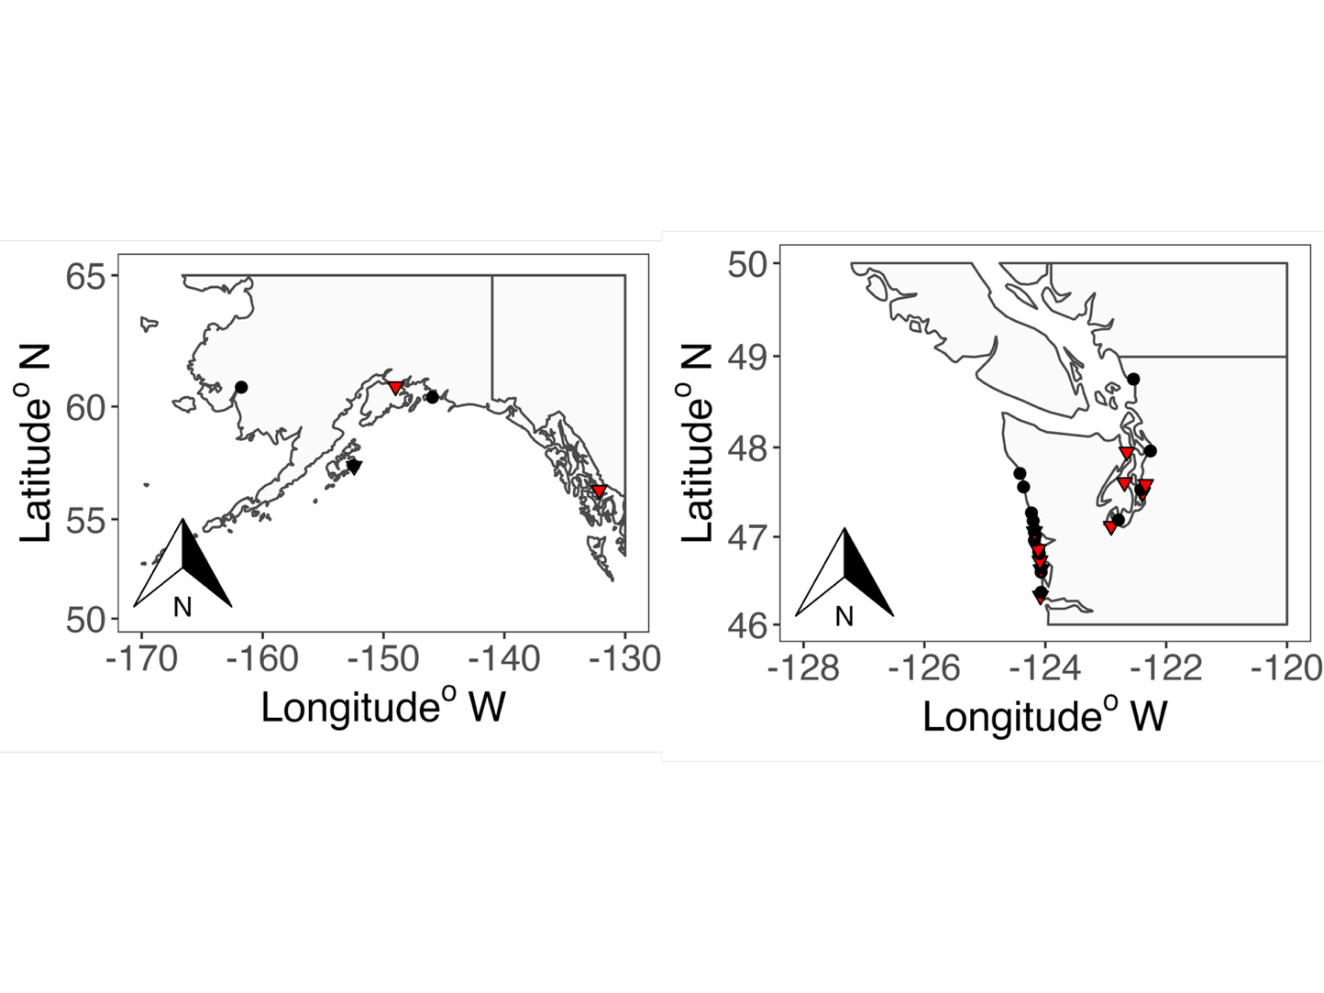
Figure 1: Locations of gray whale strandings utilized for the present study. Females are black circles, males are red triangles. The left map is the Gulf of Alaska, whereas the right map is northern Washington, in the United States to southern British Columbia, in Canada.

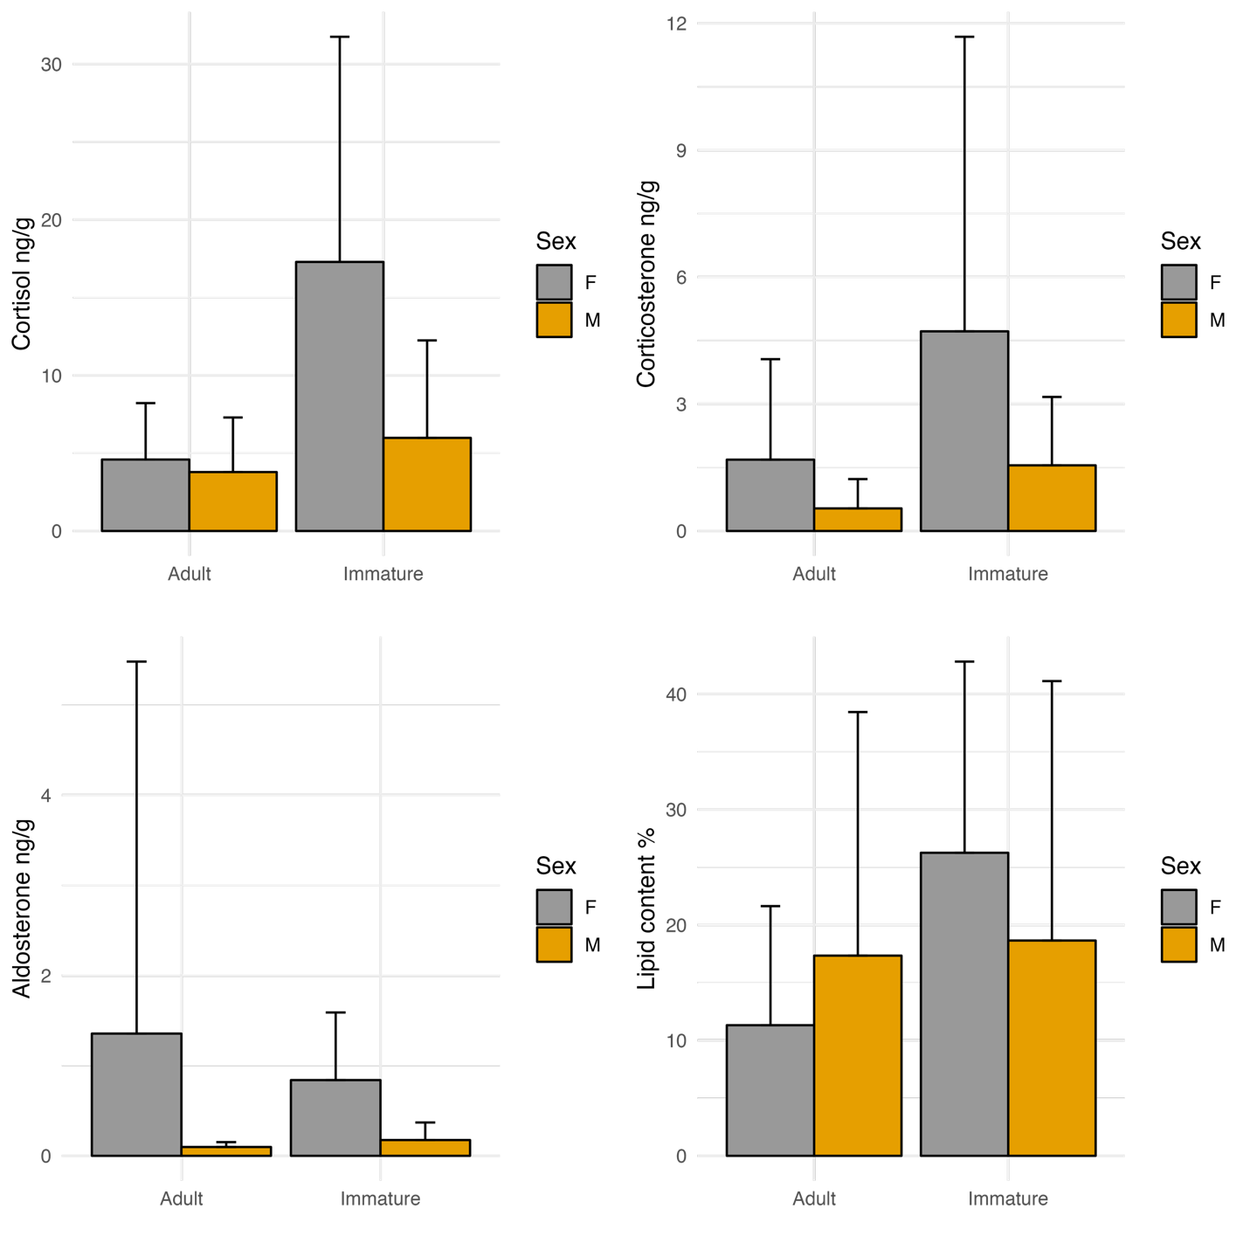

Figure 2: Hormone concentrations and lipid content in relation to age class and sex. Log-transformed concentration of cortisol and corticosterone were significantly different between adult and juvenile whales

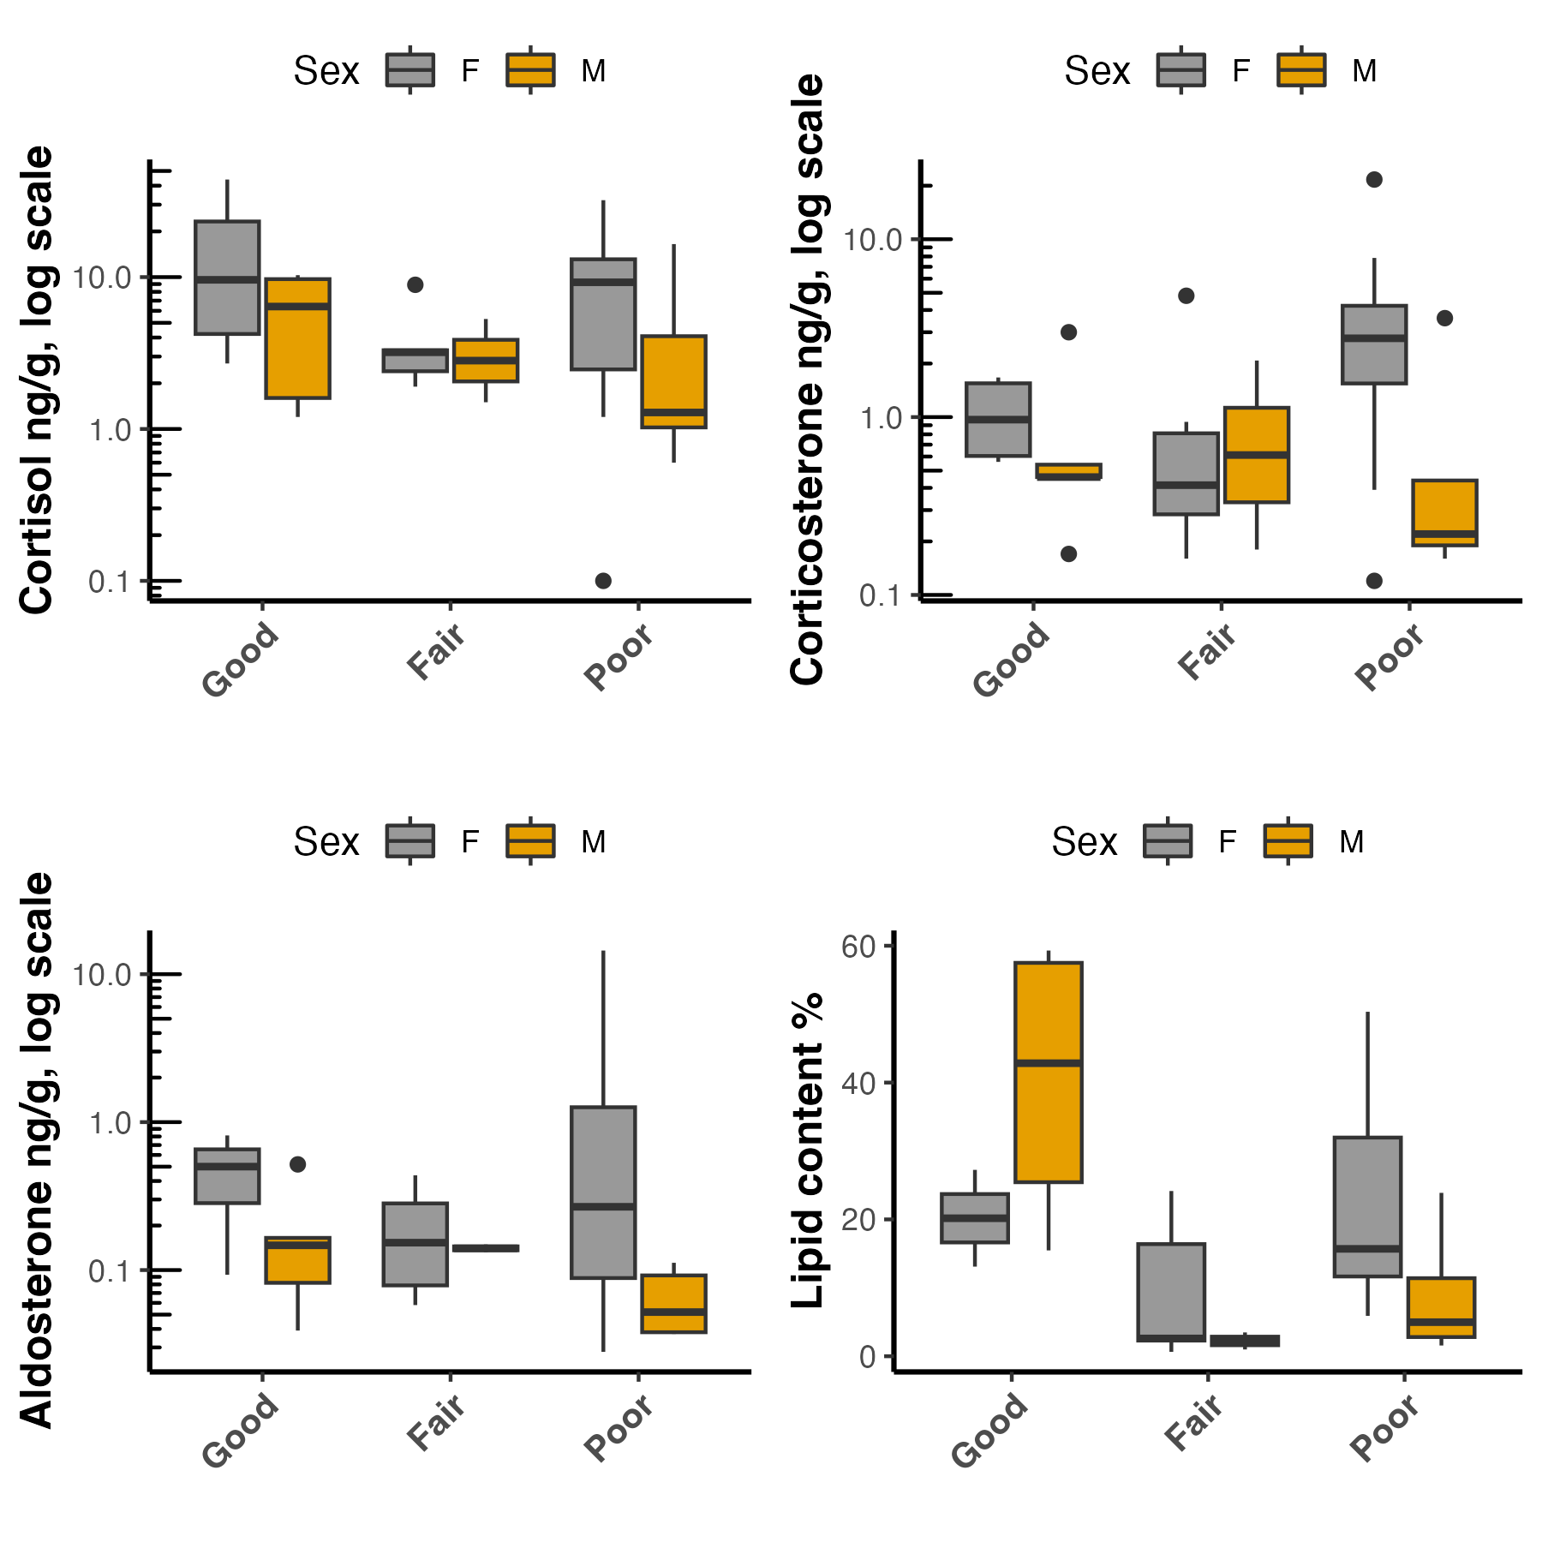

Figure 3: Hormone concentrations and lipid content in relation to body condition. Cortisol, corticosterone and aldosterone concentrations were not significantly different among three categories of body conditions. However, lipid content was significantly higher in individuals in Good compared to those in Fair (p= 0.04) body condition. Hormone concentrations are shown on a log10 scale.

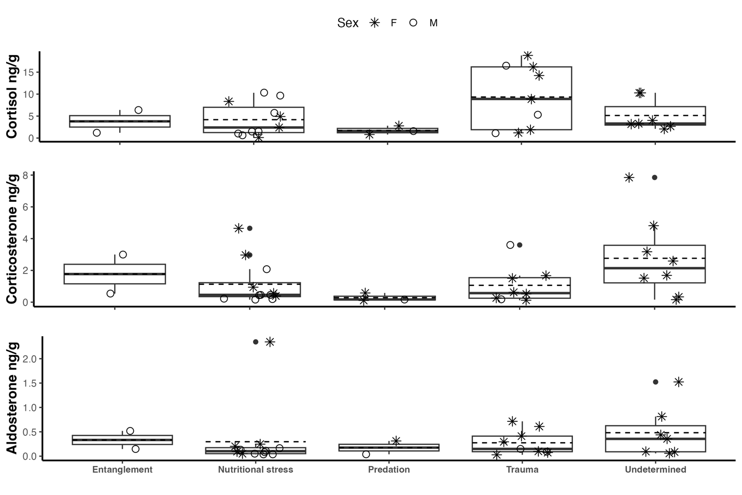

Figure 4: Hormone concentrations across cause of death. No significant difference was found in cortisol (a), corticosterone (b) and aldosterone (c) concentrations across the different cause of deaths.

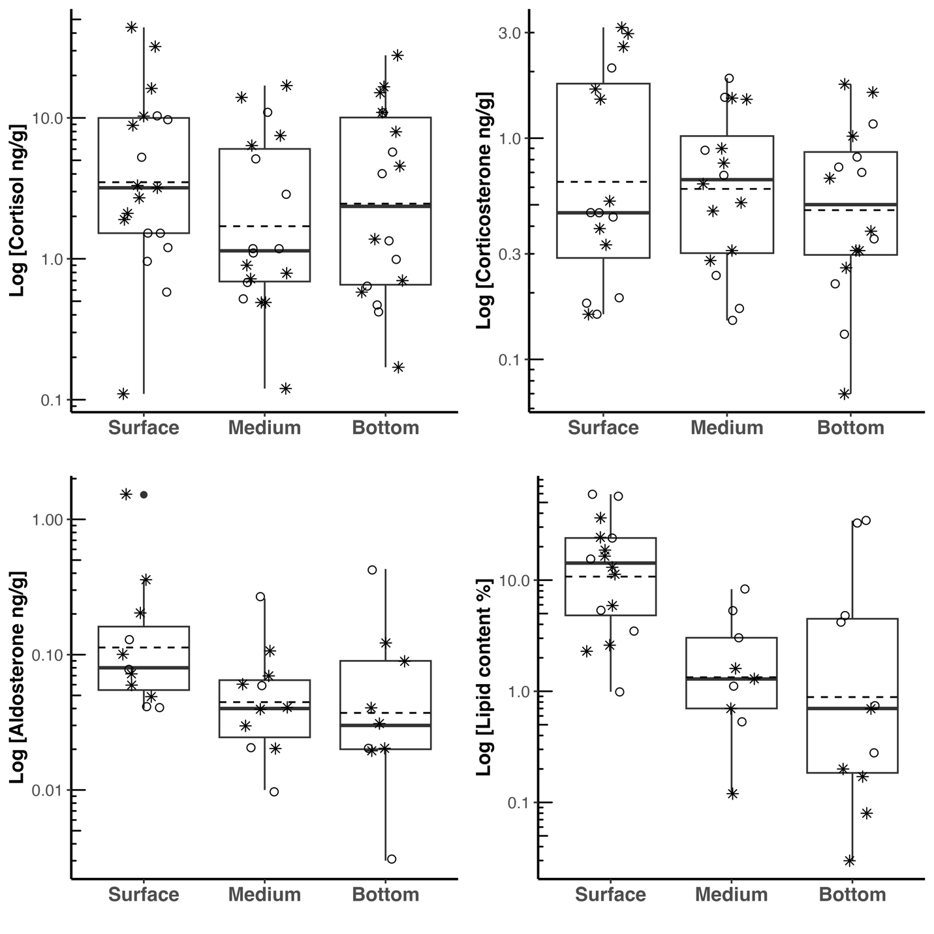
Figure 5: Log-transformed hormone concentrations(ng/g) and lipid content (%) across blubber depth in samples from stranded female (*) and male (°) gray whales. Concentrations of cortisol and aldosterone, but not corticosterone were significantly elevated in the surface layer. Similarly, lipid content was higher in the surface layer, compared to the medium and bottom layer.

